Setting up Application Environment IBM Cloud CLI Installation

|  |  |
| --- | --- |
| Date | 09 November 2022 |
| Team Id | PNT2022TMID24292 |
| Project Name | Plasma Donor Application |
| Maximum Marks | 4 marks |

**Step 1:** Login to cloud account

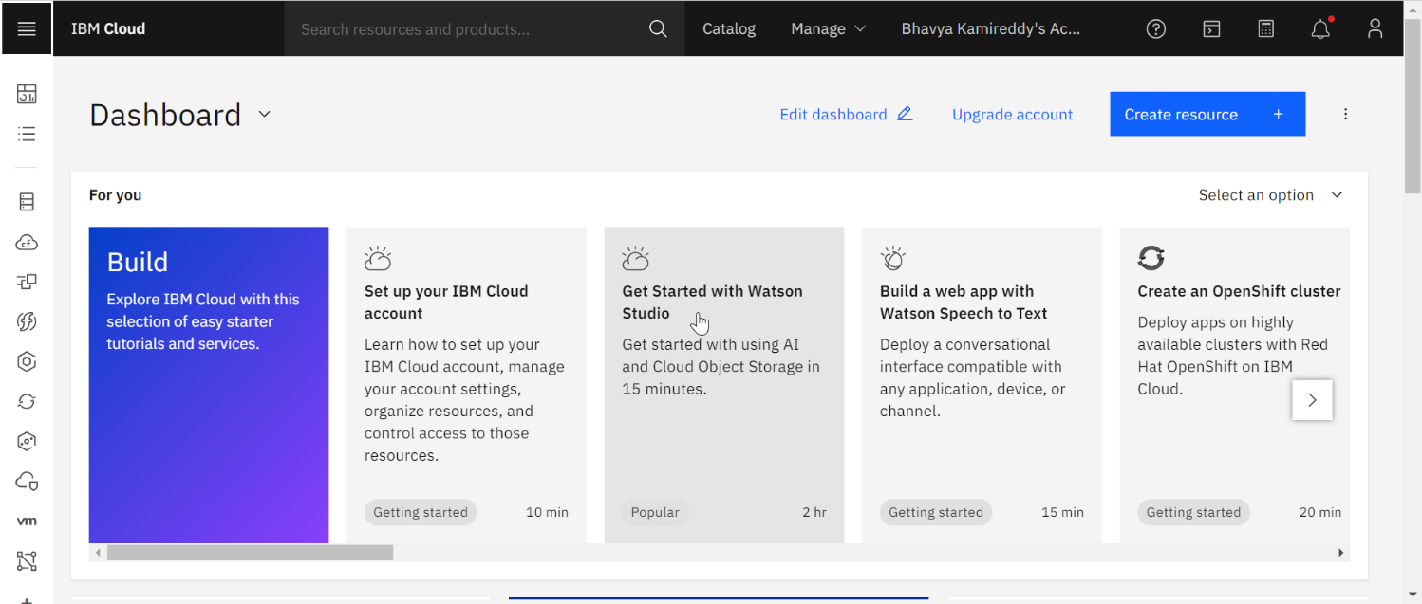

**Step 2:** click container registry

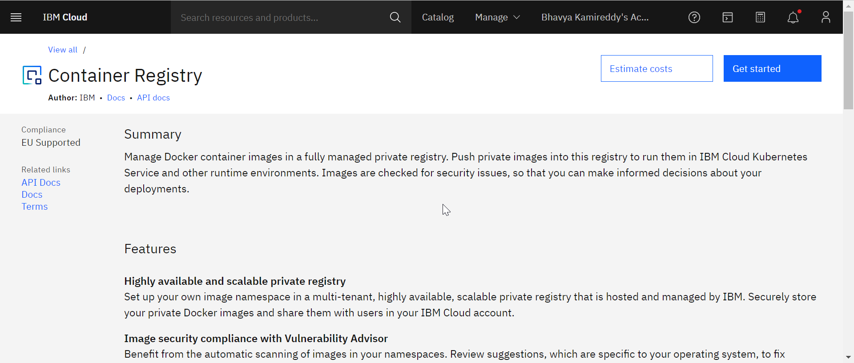

**Step 3:** Click quick start and install the IBM cloud CLI

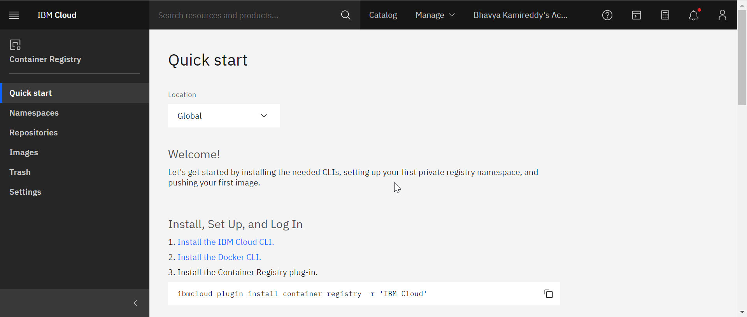

**Step 4:** Choose the correct version for the system

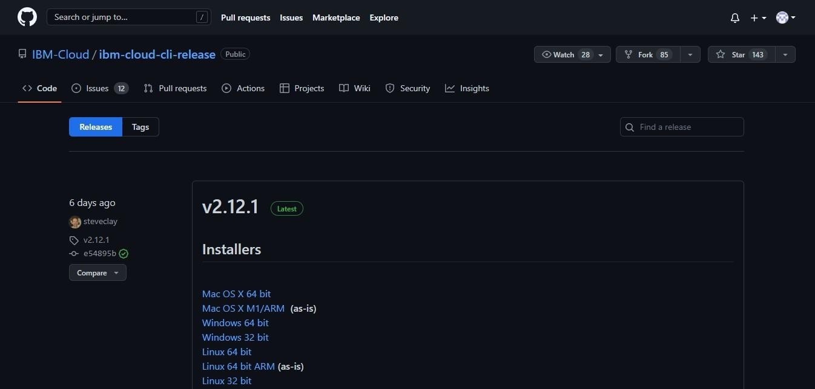

**Step 5:** click next and setup finish

